Insect modeling with individual observations: survival

BioSIM is able to calibrate parameters of 16 daily survival rate equations (see SuvivalEquations.pdf for equation definition) based on survival at fixed or random variable temperature regime as long as the temperature was recorded, for example with a HOBO logger.

Using HOBO recorded temperature let the possibility to:
- Use data even if the growing chamber did not work correctly
- accelerate when thew experimentation is to long or mortality is too high
- slow down experimentation when mortality to too high

All calibration is based on the Régnière 2012 article and used a Simulated Annealing algorithm do optimization parameters.

In this tutorial, you will learn how to format your data, define BioSIM component to calibrate daily survival equations and plot your result with R.

When curve is fitted, user can use the BioSIM model base template to implement a new model in C++ and add it to BioSIM model library. Help to this task can be made by BioSIM team. We will make a look how to use the class CSurvivalEquation to compute survival

Preparing the data

Input files to prepare
- Survival input file
- Temperature input file (in case of random temperature regime)

all input files must have a CSV (comma separate value) text format. All mandatory columns must be present (in any order). BioSIM will ignored all others columns.
All files must be in the “Input” sub directory of the BioSIM project.

Survival input file

The survival input file is composed of 5 mandatory columns:

1 | Variable | The variable name (ex “Egg”, “Larva”, “Pupa””Adult”)
2 | T | The treatment temperature. Can be a temperature in case of fixed temperature or a text ID like “Room01” when is a reference to an ID in the temperature input file
3 | MeanTime | Mean time (in days) to complete the stage with this treatment
Optional | TimeSD | Standard deviation of time. Optionally for plotting
4 | N | Number of individual at the beginning of the treatment
5 | Survival | Number of survival insect that complete the stage

The temperature input file have 2 mandatory column

1 | ID | ID of the treatment. For example “Room01”
2 | T | All hourly temperature [°C] since the beginning of the experimentation.

First Guess Calibration of survival

To calibrate survival, we fit parameters of daily survival equation to maximize the log likelihood based on the probability (Poisson distribution) of treatment group to die during is mean time longevity.

The first step will be to test all models to evaluate the most appropriate model for the data.
We assume here, you already have created a BioSIM project and the input data need are copied into the input sub directory of the project
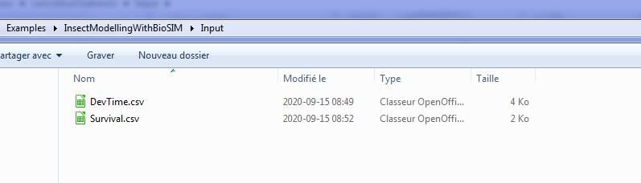

In BioSIM, add a new group() name “Survival” and add a new “Curve Calibration” component().
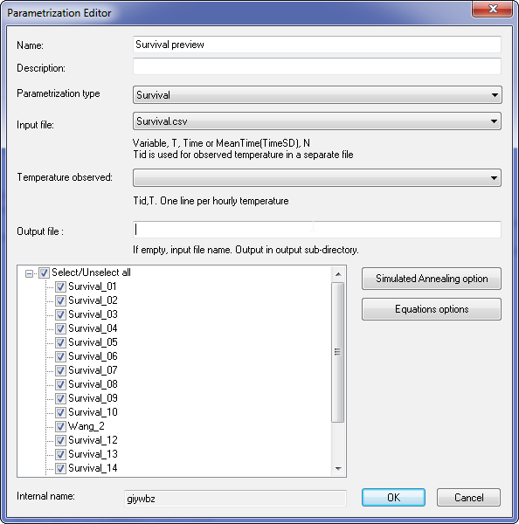
In the Parametrization Editor, select “Survival” that let BioSIM to calibrate survival equation parameters.

Select your input file, in this case Survival.csv. Because this file only have fixed temperature, there is no temperature input file.

You can let the output file name empty. By default BioSIM will save result into the “Output/” sub directory of the project with the same name as the input file.

Select all development rate equatio.

The Simulated Annealing options let the possibility to change the internal way BioSIM try to find a best parameters. You can use the default values.
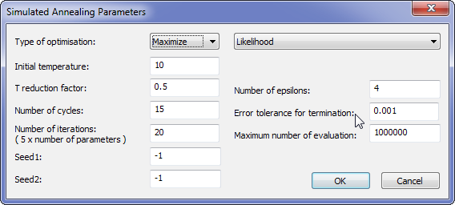

The Equations options let the possibility to define the parameters initial values and its range separately for each model. You can use the default values.
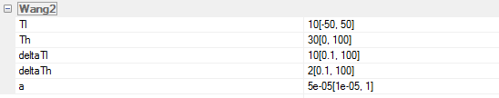

Click on OK

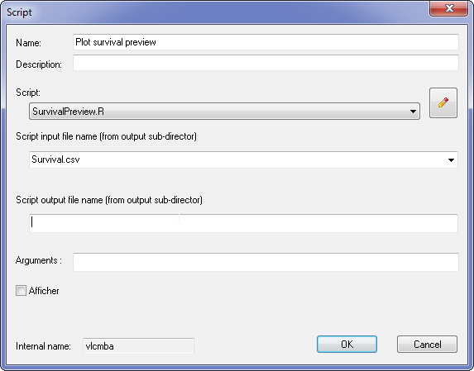
Add a new script component () on the survival component().

Select the “SurvivalPreview.R” script and enter “Survival.csv” as name of the input file. This file will be automatically created by the parametrization curve component.

Click on OK

To execute these tasks, unchecked all other tasks and click on Execute Checked ()
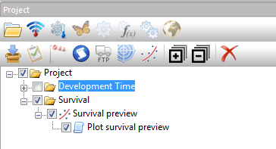

It is a relatively short process. To give an idea, on a Pentium I-7 with 8 CPU, BioSIM took ~5 minutes to calibrate 16 equations for the 8 variables (128 equations)

Analyzing the result

When finished, you will find the “Survival.csv” result file into the “/output” sub-directory of the project.
The output file contain the following columns:
Variable | Name of the Variable, same as input, for example “Egg”
EqName | Name of equation, for example “Briere2_1999”
P | Parameters name and estimated value, for example To=2.545675e+01...
Eq | The R expression equation used by R parse function
Math | The mathematical representation
AICc | The Akaike information criterion
maxLL | The maximum log-likelyhood

If the script file was correctly executed, the images of all fitted curve with observation will be created into the “/image/” sub directory of the project.

Overall results:
EqName | maxLL
Wang_2 | -14.00753
Survival_18 | -14.11461
Survival_10 | -14.16389
Survival_03 | -14.32894
Gompertz&Makeham | -14.75880
Survival_09 | -15.06285

We have mainly 6 types of curve:
drop at low and high | Drop at high only
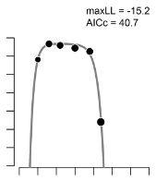 | 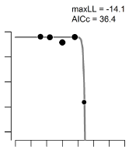
Drop at low only | Progressive drop
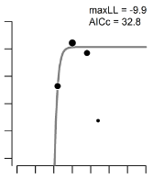 | 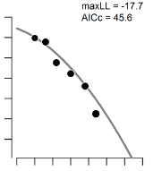
Unlike (1) | Unlike (2)
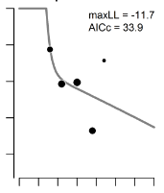 | 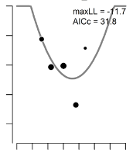

For example, Survival of L. osakensis egg:
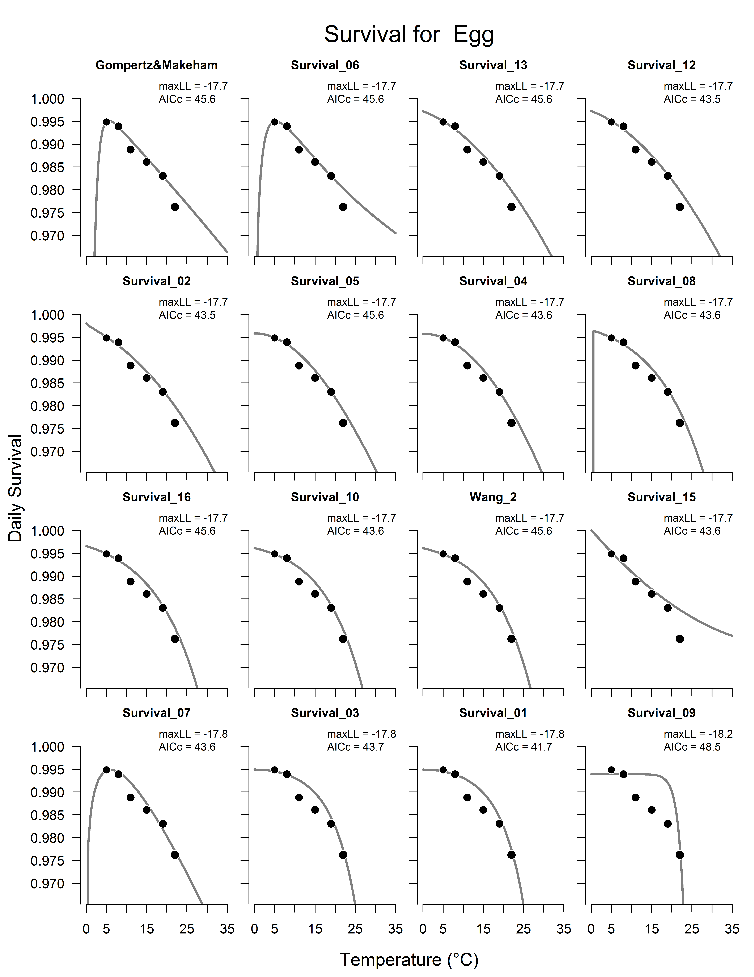

Sometime, it’s is more difficult to identify a survival pattern. For example the L1 stage:

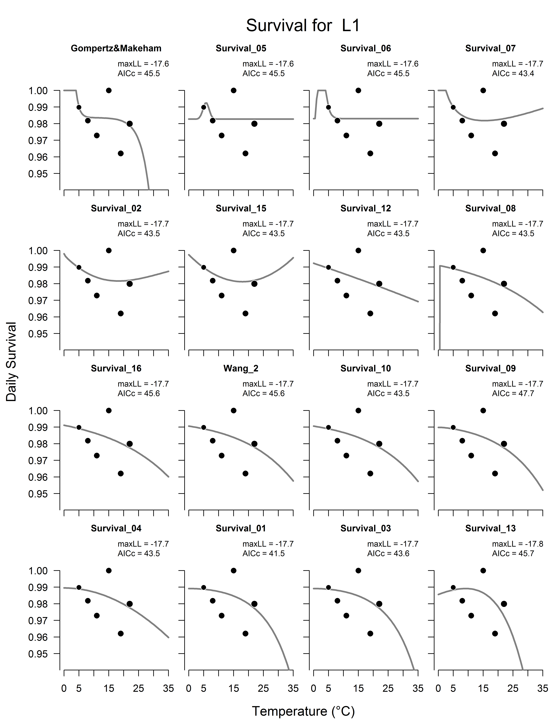
it’s not clear witch curve to select for each stage. Witch one is the best? it’s a good question. Here, we need to choose different model for each stage but we can keep in mind to minimized the number of models selected to simplify the writing of the article.

After examining each stage in detail, we choose these models:
Variable | EqName
Egg | Gompertz&Makeham
L1 | Wang_2
L2 | Wang_2
L3 | Gompertz&Makeham
L4 | Gompertz&Makeham
Larva | Survival_03
Prepupa | Wang_2
Pupa | Wang_2

So we limit the number of different model at 3.

Copy the file “/output/Survival.csv” and rename it “/output/SurvivalFinal.csv”. Edit the file and keep only the chosen model for each stage.

Add a new script component and fill it as follow
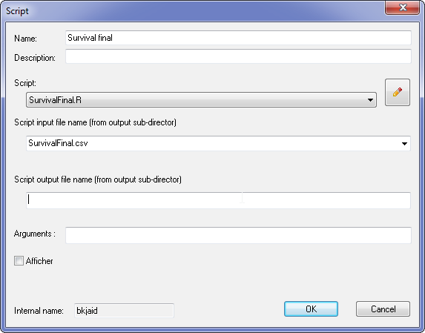

After the script was run, you will find 2 graphics files.
Survival 1
The first column is the daily survival 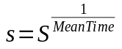where 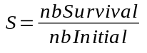. The daily survival is variable on witch the parameters are estimated.
The second columns is the observed development time points and the simulated line take from the file “/Output/DevTimeFinal.csv”.
The third column is overall survival 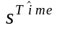.
Survival 2
Use of the class CsurvivalEquation in C++

The development rate can be directly computed from the class CSurvivalEquation

static const CSurvivalEquation::TSurvivalEquation S_EQ[LOF::NB_STAGES] =
{
CsurvivalEquation::GompertzMakeham, //egg
CSurvivalEquation::Wang2, //L1
CSurvivalEquation::Wang2, //L2
CsurvivalEquation::GompertzMakeham, //L3
CsurvivalEquation::GompertzMakeham, //L4
CSurvivalEquation::Wang2, //PrePupa
CSurvivalEquation::Wang2, //Pupa
};

static const double P_SUR[LOF::NB_STAGES][6] =
{
{-2.068145e-01, 4.470376e-03, -2.542096e-01, -9.996289e-01, 1.208148e+00},//egg
{+1.376867e-02, 1.660348e-02, +9.161862e+02, +1.647764e+01, 2.360542e-03},//L1
{+5.234181e+00, 1.921650e+01, +2.878089e-01, +1.041043e+00, 3.780321e-02},//L2
{-1.398349e-03, 2.247845e-01, -3.206069e-01, -1.829357e-02, 1.265047e+00},//L3
{-3.977939e-01, 2.359789e-02, -3.816586e-01, -9.954729e-02, 1.633458e+00},//L4
{+9.536743e-05, 3.249730e-03, +9.562198e+02, +1.207364e+01, 2.253732e-03},//PrePupa
{+1.293211e+01, 1.881825e+01, +1.570737e+00, +1.824073e+00, 5.332873e-03},//Pupa
};

//daily survival
vector<double> p(begin(P_SUR[s]), end(P_SUR[s]));
double ds = max(0.0, min( 1.0, CSurvivalEquation::GetSurvival(S_EQ[s], p, T)));

and individual survival for each time step can be compute with

bool bDeath = false;

//time step survival
double S = pow(ds, r);

//Computes attrition (probability of survival in a given time step, based on development rate)
if (RandomGenerator().RandUniform() > S)
bDeath = true;

where r is the aging rate of the time step.

Reference

Régnière, J., Powell, J., Bentz, B., & Nealis, V. (2012). Effects of temperature on development, survival and reproduction of insects: experimental design, data analysis and modeling. Journal of Insect Physiology, 58(5), 634-647.

Sporleder, M., Tonnang, H. E., Carhuapoma, P., Gonzales, J. C., Juarez, H., & Kroschel, J. (2013). 23 Insect Life Cycle Modelling (ILCYM) Software–A New Tool for Regional and Global Insect Pest Risk Assessments under Current and Future Climate Change Scenarios. Potential invasive pests of agricultural crops, 3, 412.

Tonnang, H. E., Sporleder, M., Carhuapoma, P., González, J. C., Juarez, H., & Kroschel, J. (2011). Insect Life-Cycle Modeling (ILCYM) Software: A new tool for regional and global insect pest risk assessments under current and future climate change scenarios.

